

Self-Employment Assistance
  - Sea to Valley Startups
Promoting small business ownership and self-employment to create jobs, grow the economy and improve labour outcomes, across the Barossa Valley, Clare Valley, Yorke Peninsula, and the Mid North in South Australia.

What is Self-Employment Assistance?
Self-Employment Assistance can help you turn your business idea or existing small business into a viable business. The program allows you to choose the level of support that meets your needs and the needs of your small business.
How Self-Employment Assistance can help
Self-Employment Assistance can help you with your business idea or existing business through its flexible services including:
- Accredited small business training (optional)
- Blogs
- Business advice sessions
- Business expenses
- Business health checks/Get Stuff Done sessions
- Business plan development
- Events
- Exploring self-employment workshops
- Promotion and marketing
- Referrals to and from small business support programs and services
- Stakeholder engagement
- Tailored support over a 12 month package of Small Business Coaching.
You may also be eligible for financial support while you start and run your business as part of Small Business Coaching.
Working with owners of existing micro-businesses; unemployed people and job seekers; those who are under-employed and seeking a side hustle; Culturally and Linguistically Diverse people, refugees, people with disability, carers, people who are semi-retired or retired, and Indigenous Australians.

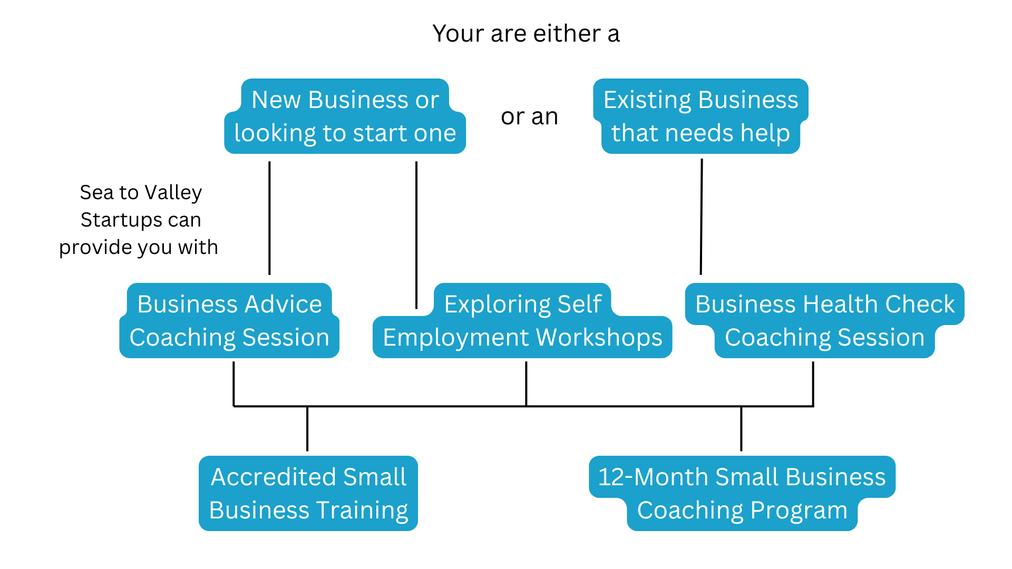
The program is open to people who are unemployed, under-employed and owners of existing micro-businesses (with up to 4 employees) who need support for your business.
Aiming for outcomes of Commercially viable and successful small businesses; Creating work and earn an income; Overcoming barriers; Running a viable small business; Starting a business; and Sustainable self-employment.
Eligibility
To be eligible you must:

be at least 15 years of age (a person must be 18 years of age to access Small Business Coaching)
- not be enrolled in full-time education

not be prohibited by law from working in Australia

not be an overseas visitor on a working holiday visa or an overseas student studying in Australia

not be an undischarged bankrupt.

deemed to have a viable business or business idea (discuss with Sea to Valley Startups)

Transition to Work participants are only eligible to access Exploring Self-Employment Workshops

Some services available through Self-Employment Assistance will also have additional eligibility criteria. For example, to access Small Business Coaching you must have an eligible business idea or existing business. This means your business idea or existing business must:

be either a new business or a micro-business (up to 4 employees) at risk of not operating commercially

be assessed as viable by your Self-Employment Assistance provider

have an independent business structure

be lawful and capable of withstanding public scrutiny

be established, located, and operated solely within Australia

be structured so you will maintain a controlling interest over the business through your time accessing the Services.

Helping people to start successful businesses. This flexible self-employment program allows Australians to access tailored support to start and run viable small businesses.

Facilitators
- Scott Perry, Founder ACE Speaking & Pitching; Co-Founder TL Plumbing & Building; Entrepreneurship Enabler at Switch Start Scale; Facilitator for Sea to Valley Startups; Inventor & Investor; MC, Pitch & Public Speaking Coach & Mentor; Product Development Manager; Speaker & Trainer.

- Abbie Allen, Founder Lifestyle Elements Concierge, Founder The Concierge Society (Mentoring), Facilitator for Sea to Valley Startups
- Wendy Perry, MD of Workforce BluePrint; Founder at Switch Start Scale; Facilitator for Sea to Valley Startups; Chair of Australian Entrepreneurs Alliance (AEA); Board Member for Propel SA; Investor.

Funded Services and Next Steps
Funded by the Australian Government, via Workforce Australia, book in for a 15 minute chat here, email admin@workforceblueprint.com.au or call 08 8387 9800 to see if Self-Employment Assistance is for you.
Locations to access services include Clare, Peterborough, Port Pirie, Tanunda, Kadina, and Yorke Peninsula providing participants with sites across the region, plus online options as well as on location at your place. Please join the Facebook group to keep in touch and the Meetups across the region. Check out Blogs and What’s On plus Support including networks across the region.

Please reach out via social media channels, email or call, to talk about Self-Employment and the assistance that you may be able to tap into.
Phone: 08 8387 9800 or email admin@workforceblueprint.com.au ; Scott Perry, +61 400 096 511, scott@seatovalleystartups.com.au ; Wendy Perry, +61 416 150 491, wendy@seatovalleystartups.com.au.

