Workplace Safety
Reporting Tools

A training guide to explore the tools and processes used in maintaining WHS Logs and Registers to support effective Management.

Table of Contents

Introduction – PDCA and Managing Safety 2
Risk Management Principles 3
Initial Reporting – Gathering the Information 7
The Reporting Process 8
Information Management Principles 11
Data Entry and Management 14
WHS Register Context 16
Effective Management Reporting 19
Good Record Keeping 21

Note: This material is a basic work instruction and should be used in an environment where participants have an understanding of basic quality management principles such as the Plan-Do-Check-Act methodology as a minimum prerequisite. When used in training the facilitator must customise the training delivery by using examples of hazards, risks, compliance issues and system activities that participants will be familiar with and that can be used workshop in discussion and activities.

Introduction – PDCA and Managing Safety

It is important for anyone involved in managing or administrating a workplace safety system to understand the Plan-Do-Check-Act Cycle (PDCA) in relation to Risk Management. Without this knowledge it will be more difficult to effectively generate system level improvement. Actions will tend to be reactive rather than proactive and remedial work may turn into a cycle of re-work.

The processes used in maintaining WHS information within Logs and Registers is directly linked to the PDCA approach in the way in which information is initially recorded and then processed. Management of the information must consider what the data demonstrates in regard to trend analysis and the effectiveness of controls that are being applied. The broad failure of the system will result if inappropriate use of the tools is produced by restricting their application to ‘data entry’ only behaviour.

The WHS Tools covered in this training guide include:

- Hazard Register (record of the broad high level hazards and risk controls used).
- Substances Register (record of various substances used e.g. dangerous goods and the risk controls used),
- Plant Register (record of key plant and equipment used and the risk controls used),
- WHS Event Log (record of hazards identified through either proactive means or incident based events, and the risk controls used), and
- Reporting tools (routine site based report requiring commentary, and live data generated graphs).

The principles in design of the tools include:

- Only relevant data – one worksite one workbook
- Integration of relevant information
- Single point of entry for event based data
- Live management reporting tools

The WHS tools are simply Excel Workbooks with a number of task dedicated Worksheets. As such the effectiveness of the tools is directly related to the quality of information entered and timeliness of actions recorded.

Note: Tools are an aid to management activity not a substitute for management action. Discipline and behaviours necessary to achieve a satisfactory safety performance must be established and maintained within normal workplace culture.

To achieve this some attention needs to be focused on behavioural prerequisites:

- Proactive attitude: identify hazards and treat the threat before an event occurs
- Accurate and timely reporting: make data relevant and useful
- Effective Management response: timely action and feedback

Risk Management Principles
Risk management underpins every aspect of the WHS Tool Workbook.

How significant a risk is can be determined by establishing 1) how likely it is to happen, and 2) what the consequence is (outcome) if it does occur.

People view likelihood and consequence differently depending on their own experience, knowledge and point of view e.g. Manager, Worker, or Customer. To help resolve the potential variation in performing a risk assessment there are standard terms and definitions provided in the Workbook. This decision making tool is called the Likelihood and Consequence Model.

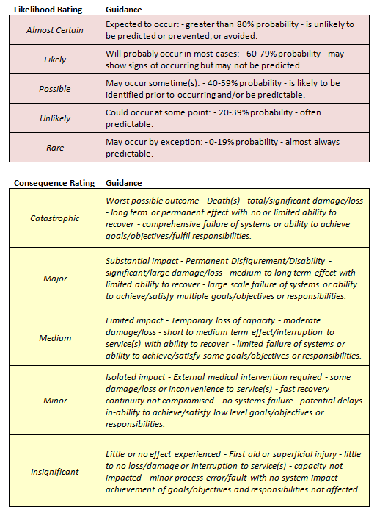

When determining the likelihood and consequence refer to the Model and then, once you have a justified reason for selecting the likelihood and consequence refer to the Risk Matrix below which is contained in the Workbook.

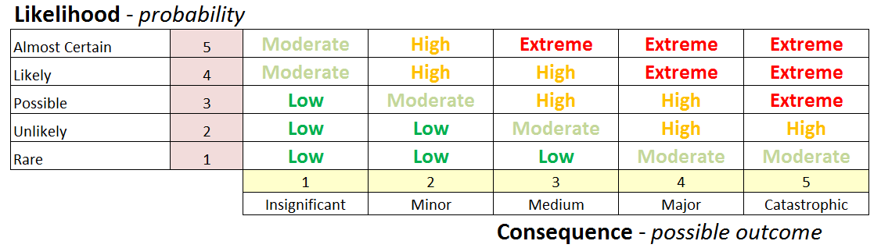

Using the two parameters you have chosen identify the point they intersect on the matrix, this will provide you with the Risk Rating. Once you have established the Rating you can prioritise and address the risk using the Hierarchy of Controls.

To help determine priorities you can use the numbers associated with each parameter and combine them. The higher the total the higher the priority (multiply the numbers).

An assessment of Risk is undertaken at two (2) separate times:

- When an initial entry is made into either register or log. This Risk Assessment determines the ‘raw’ level of risk associated with the item without any additional controls being applied i.e. if left as currently managed or unmanaged,
- When controls have been applied. This Risk Assessment determines the ‘residual’ level of risk that remains once controls have been identified and applied.

The objective of the Risk Management activity is to identify and treat risks aggressively to reduce the residual risk as much as reasonably practicable by using the hierarchy of controls. This process limits either the likelihood of occurrence and/or the consequence if the risk event is experienced.

The Hierarchy of Control (must be used in order, can be used in combinations)

To manage the risk can we?

1 – Eliminate: Get rid of it, Don’t use it, Don’t do it – if not then,
2 – Substitute: Use an alternative with less Risk – if not then,
3 – Isolate: Remove people from the Risk – if not then,
4 – Engineer: Provide solutions to reduce Risk e.g. barriers, maintenance – if not then,
5 – Administration: Provide Procedures and Training-– if not then,
6 - Personal Protective Equipment (PPE): Supply individuals with barrier devices

Short Term v Long Term Control

One thing that is very important to remember is to act fast to have an immediate impact to reduce the level of risk to safety.

It is not an acceptable position to enable a risk to safety i.e. hazard continue to present a threat based on the ideal solution requiring time and/or funds to achieve.

Principal Safety Rule

The immediate risk to safety must be quickly and practically addressed. Do something about it!

Undertake investigations quickly (events involving plant use or safety devices, moderate, high and extreme risks, and medical treatment require formal investigation). Do not remove anything (other than to make safe) if the event was associated with a regulatory reporting obligation (mandatory/notifiable event).

Some of the simple yet effective ways to manage risks in the short term include but are not limited to:

- Temporary physical barriers
- Increased signage
- Exclusion zones
- Increased training
- Warning devices (lights/buzzers)
- Increased supervision/contact
- Reducing expose times
- Rescheduling work/shift arrangements

Once initial controls are in place the medium and longer term solutions can be pursued. The effectiveness of the current controls applied will need to be monitored more frequently given their temporary nature.

Feedback and effective communication and consultation with effected stakeholders will be vital in treating the hazard, managing the risk and demonstrating a sound proactive management response to safety issues.

If you fail to implement quick effective controls to address the risk you succeed in defeating a safety culture.
NOTES:

Initial Reporting – Gathering the Information

Gathering accurate and timely information is one of the foundations to making decisions and taking action to manage safety. Without it managers, supervisors and system administrators are left to try and manage the unknown.

Note: Errors are likely occur in reporting particularly in the early stages of establishing a process or when new people join e.g. maintenance issues on Hazard Reports however it is up to supervisors and managers to eliminate these errors from the WHS system data and address the need for training. This must be approached with a view to improve reporting outcomes and not negatively impact a healthy reporting culture.

The priority for managers is to generate a culture where people feel safe and confident to report issues. An equal priority is to enable those making the report to do so accurately and with a good understanding of what will happen once a report is made.

Five basic steps to improve reporting cultures:

- Provide simple Reporting Tools – easy to access, easy to use
- Provide clear definitions – what to report to who and when
- Provide decision making tools – increase report accuracy
- Provide effective training – induction, coaching and mentoring
- Provide effective feedback – demonstrate actions and respond with information

Culture Rule Number One

Persons responsible (supervisors, managers) must review the information provided in the initial report and only add relevant data into the WHS Tools. Direct the people to the correct reporting document to use on receiving verbal reports where ever possible.

Culture Rule Number Two

Persons responsible (supervisors, managers) must provide timely feedback on the actions (principal safety rule) taken in regard to the information received, including any reclassification activities e.g. redirecting a reported Hazard to Maintenance as a work request.

Culture Rule Number Three

Persons responsible (supervisors, managers) must maintain the records of the initial report in a logical and easily accessible manner, including any record of reclassification activities e.g. redirecting a reported Hazard to Maintenance as a work request. To achieve this, a folder or file will be maintained with reports received filed in order of receipt with a section dedicated to copies of reclassified reports.

The Reporting Process

WHS EVENT – Injury, Near-miss (lucky no injury), or Hazard identified (condition or substance is a tangible threat to safety).

MAINTENANCE REQUEST – Plant, equipment, building or structure that requires alteration or repair (no tangible threat to safety).

PERFORMANCE MANAGEMENT – Actions of individuals outside of expected behaviours, procedures, and performance standards (Note: may also result in WHS Event reporting).

UPDATE WHS EVENT DATA – following immediate action and investigation ensure that information relevant to the new/revised controls and outcomes are entered into the WHS Event Data Sheet. Include important details such as who was involved in any formal investigation and, when it occurred. Make sure that the Investigation Report and associated record note the WHS Event Data reference number.
NOTES:

Information Management Principles
Successful management and use of data to inform decisions

Foundations

The basic principles of information management are to keep it simple, keep it current, and keep it relevant.

A definition of Information:

The presentation of collected data as facts, lessons learnt or knowledge acquired as a result of trend analysis, statistical reviews and management activity.

Establishing effective practices to manage, monitor, and maintain information systems are vital within any organisation. Without a process to support the activities information systems quickly degenerate into the very basic forms of data silos.

To avoid data silos and sustain effective information management systems processes must be established to;

- Define accountabilities and expectations for use
- Assign responsibilities for entering and maintaining data
- Define reporting arrangements
- Manage review of ongoing value and effectiveness of the tools

Transcribing a Report – The point of Data Entry

Data entry can be subject to errors especially where the capture method is ‘free text’ rather than requiring a choice from a set of predetermined values i.e. a ‘drop down list’. Therefore the WHS tools covered in this guide utilise ‘drop down lists’ where ever possible to help eliminate data errors related to spelling or format. To enable the raw data to be traced and verified, the log or register number from the new entry in the tool must be transcribed onto the original hard copy report.

Regardless of the types of practical assistance and controls provided within the tools some discipline of data review should be routinely undertaken. These reviews would seek to identify and eliminate discrepancies and improve continuity for all users.

The Workbook Environment

Every user must familiarise themselves with the WHS Tools Workbook environment. Users will not require high levels of proficiency in the use of Microsoft Excel however, they will be required to demonstrate the capability to navigate both the contents of the Workbook, and the structure of the Worksheet registers, log and report designs.

Embedded notes and user prompts are in place throughout the Workbook to assist in decision making and data entry requirements and formats. These can be accessed by placing the ‘cursor’ over the cell or information display in the active Worksheet.

Workbook and Worksheet Navigation

The Workbook has built in features called Macros. You need to enable these to experience full functionality. If you have difficulty with Macro Security due to your default settings please contact the IT Help Desk.

Navigating the Workbook (contents of the file) is achieved by selecting a Worksheet from the tabs located at the bottom of the screen.

First thing to do is enable Macro content. This message appears in ribbon towards the top of your screen. | 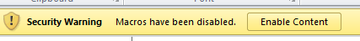  Click ‘Enable Content’
Select the tab for the sheet you want to work in. | Worksheet Tabs for Data entry or Review
Use the forward and back buttons located in the bottom left of the screen to scroll through the available Worksheets (Tabs). |   Sometimes Tabs can be hidden due to screen settings

Navigating the Worksheet (contents of the active tab) is achieved by using the tab, enter or up/down/left/right directional arrows on the Key Board or using the Screen Up/Down or Screen Left/Right slides located to the right of screen (up/down) and bottom right corner (left/right).

Left/Right Screen arrows are located in the bottom right corner. Users can also change the ‘zoom’ in view by using the (+) and (-) slider located adjacent to the number indicating the level of current screen display e.g. 100%.



The screen Up/Down are located directly above and run vertically along the side.

Once users are familiar with how to navigate both the Workbook and the Worksheets then they can focus on data entry, management reporting and how to save and print content.

NOTES:

Data Entry and Management
Add the right data, manage the outcomes, and record the evidence.

Note: It is important to recognise that the data entered into the WHS Tools are sourced from hard copies of information i.e. reports (both initial and investigations) and other supporting records such as documented risk assessments that must be retained. The use of the WHS Tools does not eliminate the need for these other records even once data has been added to the Workbook.

How the Workbook functions

The operating philosophy of the Workbook is based on a hazard management model that reflects the PDCA method of continuous improvement, and the foundation of risk management practice.

To achieve this Workbook design is reliant on the following assumptions:

- Registers contain information that is recurrent until identified as redundant,
- The Event Log contains information about activity related to items identified in the Registers,
- Reports will be used as intended and the information presented in Graphs will be selected and displayed on notice boards,
- The Event Log can be archived (saved as a PDF record) and reset (cleared) each year,
- Live Statistical and Management Reports can be routinely archived (saved as PDF) and reset monthly or annually as appropriate (will automatically reset when Event Log is cleared), and
- Information will be maintained and amended in a timely and routine manner as required.

NOTES:

WHS Register Context
All Registers function in the same way only content type varies.

The WHS Workbook tool contains a number of individual Registers. Each register has the same features and functionality but is dedicated to specific content, this includes:

- Hazards
- Substances
- Plant

Understanding Registers v Event Log Relationships

The WHS Tool makes a clear distinction between the Registers and the Event Log. The purpose of the log is to record event based issues and activity. The purpose of the registers: to record details about known risks and conditions.

Under this arrangement there is a hierarchical relationship that applies between the registers (master) and the log (servant). The log is linked to the registers and vice-versa through the reference cell contained in the Event Log.

Also worth mentioning but not covered in this guide is the relationship the registers then have with the organisation’s Risk Register(s). The overall relationship is depicted in the following diagram.

Example
Organisational Risk = Use of plant. Systems are developed at the organisational level to identify and assess forms of plant and provide training to address unique characteristics.

WHS Hazard Register = Specific types of plant related risks assessed and controls recorded. Note: Risks specific to individual plant reside in the Plant Register.

WHS Event Log = List of events related to items of plant and remedial control.
Once the required data has been added into the Registers this information needs to be used in the context of managing the overall performance and effectiveness of the Safety System. Reviews must be conducted at least annually and earlier as influenced by the rate of related event activities i.e. if there are a number of hazards raised and/or incidents occurring associated with a particular substance, item of plant of known hazard condition then a complete review of the risk assessment and control methods should be undertaken prior to any planned review date.

Routine Review = Continuous Improvement

Minimum Annual Review Steps (after saving as PDF)

- Individually review every Register Entry
- Filter the Event Log to identify related entries
- Review the related events for trends or new conditions
- Assess the hazard management controls within the Register for accuracy and effectiveness in consideration of the event trends or new conditions
- Update the risk assessments, hazard details and/or control conditions within the Register to reflect process improvement
- Copy as a record and then clear the Event Log by deleting the entries and update formatting

In this context the Event Log is used as a way to measure performance and effectiveness of Hazard Management controls already identified in the Registers. The more incidents or operational identification of hazards the greater the need to improve management control i.e. force review at the process level (recorded in the Register). This approach places a greater focus on proactive and preventive management by aligning accountability for process orientated safety performance with operational event activities.

NOTES:

Effective Management Reporting
Real time reporting, timely interventions, and capturing management responses.

Note: The Workbook provides a wide range of visual presentation options, and the ability to print information tables if preferred to share, discuss and review information. The registers and the log are there to collect information and require a lot of data capture to do this so printing those Worksheets becomes impractical. Current and future management practice must be to view these items ‘live’ within meeting environments if required for discussion rather than printing copies off un-necessarily.

Data Analysis and Reporting

The Workbook contains reporting tools which target various people within the organisation.

Staff – Monthly WHS Event Summary graphs demonstrate trends in target areas:

- Events i.e. Incidents and Hazards Raised per Month (year to date)
- Plant related Incidents per Month (year to date)
- Injuries per Month (year to date)
- Claim per Month (year to date)

Other graphs are available presenting information in different ways; these are options for use as needed from time to time. Some graph Worksheets are ‘hidden’.

Site Management – the above mentioned graphs plus Site Report:

- Incident KPI data
- Standard data tables outlining event statistics
- Live data on events such as;
  - Investigations not commenced
  - Actions commenced but not complete (open)
  - Investigations completed (closed)
  - Total number of items where actions to address risk exceeded 30 days
  - Number of items exceeding 30 days still open
- Sections where management comments on the safety performance is required

Note: Once management comments are added the report is saved as a PDF and comments cleared from the Worksheet prior to entering the next month’s commentary.

Management Report – high level report focussing on KPIs, hazards and incidents in relation to risk profile, trends of events and effectiveness of management response..
NOTES:

Good Record Keeping
Saving and managing your records effectively.

The process for entering and maintaining good quality and useful information and therefore records with the WHS Tool Workbook is very simple; complete the process by providing the required information, follow the prompts to make the entries count, and keep up the administration to maintain relevance.

Maintaining a timely approach to entering and updating the data is vital. If the timeliness of this activity diminishes then the reporting process will quickly highlight poor performance in this area. Therefore, it is not only good practice but in the manager’s best interest to ensure that administration is effective.

Electronic Record Keeping

While hard copies of the records produced may be retained for people without Network access for a short period e.g. 3-6 months; electronic records of the Workbook will be the primary method of record keeping. This will be accomplished by a process of saving the files as PDF documents and storing them in Network folders for easy future access.

Requirements for Backup and Archive as PDF

Registers – Annually, only redundant entries cleared
Event Log – Annually then cleared (part of the review cycle)
Site Report – Monthly then cleared (part of the reporting cycle)
Monthly Summaries (Event Graphs) – Annually
Management Report – Monthly
All other Graphs - Annually

Note: at any time selected or all information contained within the Workbook can be backed up and archived by saving as a PDF record.

Saved PDF files must be added to a dedicated folder marked to identify the associated year of record e.g. 1213 = Financial Year 2012-2013.

Note: There is no need or expectation to routinely print either Registers or the Event Log. The Registers can be printed on an annual basis (A3) to maintain in a hard copy for general access purposes with recognition that printouts will be potentially difficult to read due to font size, the Event Log is not intended to be a public document as it contains details covered by the confidentiality conditions of WHS and Injury Management and Rehabilitation Legislation.

Note: All original copies of Event report must still be retained in the usual manner.
NOTES:

